EARLY WARNING BULLETIN FOR FOOD SECURITY

No. 2015/04 IN THE GAMBIA Period: June 1 – 10, 2015

 Government of The Gambia | Produced and Published by The Gambia National Multidisciplinary Working Group  Focal Point: Department of Water Resources  TEL: (+220) 4227631 / 4224122 / 8905229 - FAX: (+220) 422 50 09  E-MAIL: dwr@mofwrnam.gov.gm  WEB: www.mofwrnam.gov.gm | 

- METEOROLOGICAL SITUATION

1.1 GENERAL SYNOPTIC SITUATION

The surface position of the ITD fluctuate over Central Senegal, sloping towards southern Mali, Burkina Faso. Niamey and onto Chad
Places over the Maghreb states were dry and stable with wide spread of dust patches prevailed over Mauritania and Algeria visibility ranging from 5000 -2000 m leading to reduction of horizontal and vertical visibility.
Convective cloud development resulted into severe thunderstorm outbreak and /or rain over Ivory Coast, Togo, Ghana, Benin and Nigeria.

1.2 WEATHER SUMMARY FOR THE GAMBIA
Partly / variably cloudy sometimes occasionally breezy accompanied with slight rain affected the eastern parts of the country during the latter part of the dekad.

OUT LOOK
Variably cloudy warm and humid with chances of thunderstorms and / or rain is expected over places especially in land areas during the period.

2.0 AGROMETEOROLOGICAL SITUATION

2.1 RAINFALL SITUATION

In this dekad rainfall was recorded in Fatoto (14.7mm) and Sapu (3.1mm) both in the Eastern and Middle Thirds respectively.This development has prompted some agricultural activities in these regions. In other parts of the country, no rainfall was recorded. However, this situation is different from that of last year during the same time when all the stations have recorded significant rainfall amounts.

2.2 Temperature

Average temperatures across the country varied between 28.0°C and 29ºC in the Western Third, 30. 0 ºC and 31°C in the Middle Third, 32.0ºC and 33°C in the Eastern Third. Highest minimum temperatures were between 22°C and 25°C in the Western Third, 22°C and 24°C in the Middle Third and 24ºC and 27°C in the Eastern Third. Highest Maximum temperatures were between 34.0ºC and 39°C in the Western Third, 40°C in Middle Third and 40°C – 42°C in the Eastern Third.

2.3 Winds

There were some Gusty Winds during this dekad, 64km/h in the Eastern Third, 55km/h in the Middle Third and 54km/h in the Western Third. There were no structural damages reported.

2.4 Sunshine Duration

Sunshine duration was above 7hours Countrywide.

2.5 Relative Humidity

Average maximum relative humidity (RH) was above 60% in Western Third and above 50% in the Middle and Eastern Thirds of the country respectively.

- Hydrological Situation

All the Surface Water stations (Water Level) continue to be influence by the tidal effect from the ocean up to the extreme upper reaches of the river Gambia at Fatoto. Salinity (salt content in the water) values continue to increase at Balingho, Pakaliba, Kaur and specific conductivity at Kuntaur, which has not yet detected salinity. This is mainly due to the extraction of water from the river and high evaporation. (Figure 1)

This information was recorded from the 4/22/2015 to 5/26/2015 time period and was downloaded during our last monthly data collection exercise from the 25-28th May, 2015
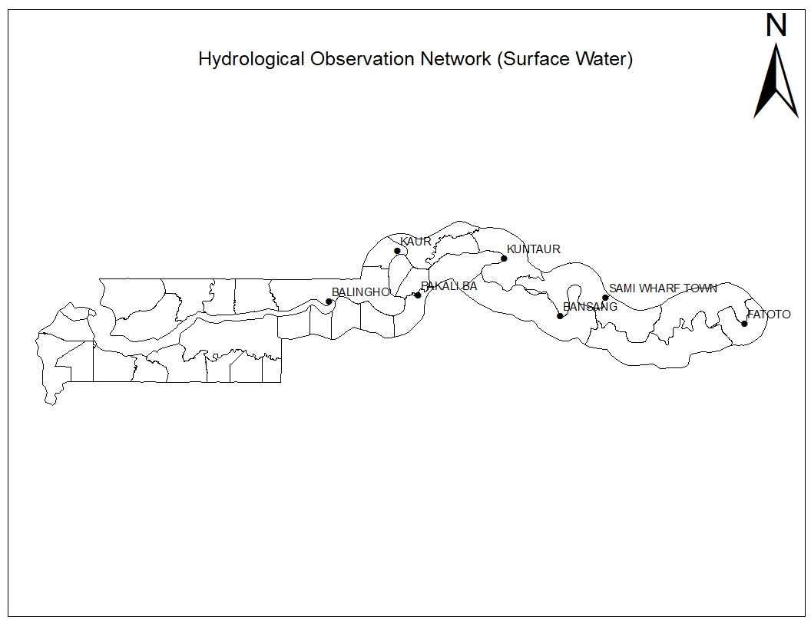
Max: 1.61m
Min: 0.08m
Sal: 25.87 PSU

Max: 2.47m
Min: 1.35m
Sal: 8.93 PSU
Max: 1.92m
Min: 0.59m
Sal: NO
Max: 32.094 /s
Min: -0.501 /s
Max: 1.61m
Min: 0.84m
Sal: 13.82 PSU
Max: 2.68m
Min: 1.66
Sal: No
Max: 32.757/s
Min: -32.647/s
Fig 1-1; the map of the Gambia showing the Hydrological Observation Network

4.0 AGRICULTURAL SITUATION

WEST COAST REGION
The major Agricultural activity in this Region continues to be field clearing, acquisition and treatment of seeds and repairing of tools.

NORTH BANK REGION
The major Agricultural activity in this Region is field clearing, the acquisition and treatment of seeds and repairing of tools. However there are some farmers in this Region engaged in dry sowing of late millet and findi.

LOWER RIVER REGION
In this region farmers are engaged in field clearing, acquisition and treatment of seeds; some farmers are also engaged in dry ploughing on their fields.

CENTRAL RIVER REGION NORTH
Community fields in the CRR North have finished transplanting on their rice fields in Tidal areas and crops are at panicle stages, however, rice transplanting is still ongoing in the same Region for Vision 2016 rice fields

CENTRAL RIVER REGION SOUTH
In this Region, transplanting is ongoing in the Tidal fields (90% completed), whilst in the Upland the major Agricultural activity is field clearing, acquisition and treatment of seeds.

UPPER RIVER REGION
Some farmers in Wulli and Jimara districts in this region have started sowing early millet after some recorded rainfall favorable for this activity. However, some farmers in other districts continue on land preparation activities, acquisition and treatment of seeds, alongside other relevant pre-season activities.

4.1 Crop Production
N/A

4.2 Crop Protection
N/A

4.3 Livestock

As part of its mandate ,the department of Livestock Services prevents and controls animal diseases through annual and bi-annual vaccination campaigns for deadly diseases such as New Castle, which have a mortality rate of 85- to 100% , Peste des petite Ruminant( PPR ) which also have a similar mortality percentage.
An annual vaccination for Contagious Bovine Pleuropneumonia (CBPP) was conducted in May, 2015 and a total of two hundred and sixty-two thousand eight hundred and thirty-four heads of cattle (262,834) were vaccinated against this deadly cattle disease.

Other diseases which continue to plaque our Livestock and pose observable production constraints include Haemorrhagic Septicaemia (H/S) , Blackquarter(BQ) which are vaccinated at field level by our extension staff during their routine clinical treatment treks.
However, a host of other important animal diseases namely trypanosomiasis, pasteurellosis, Broncho-pneumonia, salmonellosis are equally attended to by our field agents all year round.
Furthermore, farmers have started clearing their fields in preparation for the rainy season; this often leads to bushfires resulting to acute shortage of feeds, emaciation, and low productivity and heighten animals susceptibility to disease infections.

4.4 Fisheries
N/A

5.0 National Disaster Management Agency (NDMA)

N/A
6.0 National Environment Agency (NEA)

N/A

7.0 Market Situation

Table: 1 Average commodity prices per KG (in Dalasis) of selected markets - Date: 10/06/15

Source: Planning Services Unit, Department of Agriculture

Banjul ,June 11 2015
National MWG of The Gambia

Composition of MWG:  Department of Water Resources  Planning Services - Department of Agriculture (DOA)  Communication, Extension & Education Services - DOA  Animal Health & Production Services - DOA  Plant Protection Services - DOA  National Environment Agency | Direct your comments and questions to:  The Director  Department of Water Resources  7 Marina Parade, Banjul  The Gambia  Tel: (+ 220) 422 76 31 / 422 41 22 / 890 52 29  Email: dwr@mofwrnam.gov.gm

